

NCIA – National Cancer Imaging Archive

Software Design Description

Release 1.2 – User Preferences

NCIA Team:

Jon Dietrich

James Luo

Andrew Shinohara

Jin Chen

Derek Kong


Document Change Record
Version Number | Date | Description
1.0 | 01/05/06 | Initial document
1.1 | 01/19/06 | Updated after reviews

TABLE OF CONTENTS
1. Introduction 1
1.1 PROJECT BACKGROUND 1
1.2 SYSTEM OVERVIEW 1
1.3 Requirements Traceability 2
1.3.1 Relevant Statement of Work Tasks 2
1.3.2 Functional and Technical Requirements 2
2. Use Cases 3
2.1.1 New Use Cases 3
2.1.2 Changes to Existing Use Cases 11
3. System Architecture 15
3.1 Add Direct Access to Hibernate 3 15
4. Components 16
4.1 USER INTERFACE 16
4.1.1 Navigation Bar 16
4.1.2 Search Results Page – Save Query Fields 16
4.1.3 Manage Saved Queries 17
4.1.4 Search Page – Editing Saved Query 19
4.1.5 Search Results Page - Editing Saved Query 20
4.1.6 Search Results Page – Resubmit Saved Query 21
4.1.7 View Query History 22
4.1.8 Home Page 24
4.2 User interface Backing Beans 25
4.2.1 SavedQueryDTO 25
4.2.2 QueryHistoryDTO 26
4.2.3 SearchResultsBean 26
4.2.4 SearchWorkflowBean 27
4.2.5 SavedQueryBean 28
4.2.6 QueryHistoryBean 28
4.2.7 NewResultsFlagUpdater 29
4.3 MIDDLE TIER 30
4.3.1 QueryStorageManager 30
4.3.2 Criteria 32
4.3.3 CurationStatusDateCriteria 32
4.3.4 DicomQuery 32
4.3.5 DicomQueryHandler 32
4.3.6 ResultSetManager 33
4.4 BACK END 33
4.4.1 Hibernate3DataAccess 33
4.4.2 Domain Classes 33
4.4.3 Database Design 35
4.5 PROCESS TO UPDATE NEW DATA FLAG 37

Introduction
The purpose of this document is to describe the design for the User Preferences feature being developed for Release 1.2 of the NCIA – National Cancer Imaging Archive software. The enhancement will provide new functionality to allow users to save and resubmit queries, view their query history, and improve the ability to grow a community of NCIA users.

PROJECT BACKGROUND
Please refer to the NCIA Architecture Overview for background on the NCIA project.

SYSTEM OVERVIEW
Please refer to the NCIA Architecture Overview for a system overview.

Requirements Traceability

Relevant Statement of Work Tasks
The NCIA Statement of Work (SOW) Task Description contains the following items that will be implemented as part of this design:
1. Develop a user preferences function that allows users to save and execute previously submitted queries. Allow users to retrieve any new images that are submitted to the system since their last query/download. This involves:

a. Capture user’s queries and last execution date and time, and retrieve the queries at user’s request
b. Implement user preferences screens with the following functionality:
i. Recalling a user’s most recent query from previous site visits. The query can be saved and/or executed
ii. Allowing a user to query and download only the data added since the same user’s last executed query (if desired)
iii.Informing the user about new changes and new data available

iv. Collecting user feedback by providing an email address and phone number for application support and user feedback

Functional and Technical Requirements

The following is a more detailed list of requirements for this enhancement:
ID | Requirement
1 | Allow users to save an executed query
2 | Capture user's queries and last execution time
3 | Allow edit and delete of saved queries
4 | Retrieve 20 previously executed queries at user's request for re-execution
5 | Allow re-execution of saved queries
6 | For saved queries, allow a user to view only new data that has been added since the last execution of the query.
7 | Provide link to web site to inform user about changes and new data that is available
8 | Provide email address for user feedback

Use Cases
User preferences requirements were documented by a combination of adding new use cases and updating existing use cases.

New Use Cases

Save Query Use Case

Use Case Name | Save Query
Use Case ID | 12.1
Primary Actor | Researcher (User)
Trigger | User wants to save the query for future use.
Pre-conditions | User has performed a search (simple or advanced) and is viewing the results of the search on the Search Results page. The search was conducted using a query that is not already saved.
Flow of Events | 1. User enters a name to call the saved query  2. User presses the “Save Query” button
Post-Conditions | Success Condition: The query is saved in the database for the user. User is returned to the Search Results page with a message indicating that the query has been saved successfully. The message includes the name of the query. The last executed time for the saved query is updated to the current date and time. The new data flag for the saved query is set to false.  Error Condition: A query with that name already exists for this user. The user is returned to the Search Results page with error message displayed. The query is not saved. User then has the opportunity to enter a new name for the query.  Error Condition: User does not enter a name for the query and presses the “Save Query” button. The user is returned to the Search Results page with an error message indicating that the query name is required. The query is not saved. User then has the opportunity to enter a name for the query.
Alternative Flow
Related Use Case | 10.1 – Display Search Results

Manage Saved Queries Use Case

Use Case Name | Manage Saved Queries
Use Case ID | 12.2
Primary Actor | Researcher (User)
Trigger | - User clicks on the “View Saved Queries” link in the side navigation bar from any page in NCIA.  - User clicks the “Saved Queries” button while on the “Query History” page
Pre-conditions | The user has saved queries previously by saving the criteria from simple/advanced search query page.
Flow of Events | - The user is presented with a list (sorted alphabetically by query name) of all of their saved queries. For each query, the following is displayed:  - Query name  - When the query was last executed (specifying timezone of EST)  - Link to view new data for the query (if query has been marked as having new data available – see use case 12.7)  - Button to resubmit the query  - Button to edit the query  - User clicks on the query name to view details about the query’s criteria.  - User performs an action related to the saved queries (see related use cases).
Post-Conditions | List of saved queries is displayed.
Alternative Flow | If the user has not saved any queries, a message is displayed indicating that to the user in place of a list of saved queries.
Related Use Case | 12.1 – Save Query  12.3 – View New Data for Saved Query  12.4 – Resubmit Saved Query  12.5 – Edit Saved Query  12.6 – Delete Saved Query

View New Data for Saved Query Use Case

Use Case Name | View New Data for Saved Query
Use Case ID | 12.3
Primary Actor | Researcher (User)
Trigger | User wants to view new data for a saved query.
Pre-conditions | The saved query has been marked as having new data available (see use case 10.1) since the last time it was executed.
Flow of Events | 1. User navigates to the View Saved Queries page.  2. Users presses the “New Data” link for the saved query.
Post-Conditions | Success Condition: User is taken to the Search Results page with the results of the query displayed. In addition to the saved query’s criteria, the results are filtered to include only those images (and associated data) that have a curation status date later than the last execute time of the saved query. If the query has previously been run during the user’s session, the system will use the same last execution date it used the first time it ran the saved query (instead of the current last execution date) for new data during the user’s session. The name of the saved query is displayed on the Search Results page. The last executed time for the saved query is updated to the current date and time. The new data flag for the saved query is set to false when the user logs out or their session expires.
Alternative Flow | A user has previously saved a query that included criteria for collections ABC and XYZ. Then, some time later, they are granted access to collection PQR. The user then wants to view new data for all three collections (ABC, XYZ, and PQR). In this situation, they must run two queries: the saved query to view new data (which will include only ABC and XYZ as saved) and then another query to view PQR data.
Related Use Case | 12.2 – Manage Saved Queries  12.7 - Mark Saved Query as Having New Data Available  10.1 – Display Search Results

Resubmit Saved Query Use Case

Use Case Name | Resubmit Saved Query
Use Case ID | 12.4
Primary Actor | Researcher (User)
Trigger | User wants to resubmit a saved query that has been previously run.
Pre-conditions | User has saved one or more queries.
Flow of Events | 1. User navigates to the View Saved Queries page.  2. Users presses the “Resubmit Query” button for the saved query that they want to run.
Post-Conditions | Success Condition: User is taken to the Search Results page with the results of the query displayed. The results are current as of the time when the query is run. The name of the saved query is displayed on the Search Results page. The last executed time for the saved query is updated to the current date and time. The new data flag for the saved query is set to false when the user logs out or their session expires.
Alternative Flow
Related Use Case | 12.2 – Manage Saved Queries  10.1 – Display Search Results

Edit Saved Query Use Case

Use Case Name | Edit Saved Query
Use Case ID | 12.5
Primary Actor | Researcher (User)
Trigger | User wants to edit a query that was previously saved.
Pre-conditions | User has saved one or more queries.
Flow of Events | 1. User navigates to the View Saved Queries page.  2. Users presses the “Edit Query” button for the saved query that they want to edit.  3. User is taken to the “Simple Search” page. The saved criteria for the query are selected as criteria on the page.  4. User changes the criteria.  5. User presses the “Submit” button to run the query.  6. User checks the results and confirms that they want to save the query.  7. User selects that they want to update the query with the new criteria and presses the “Save Query” button.
Post-Conditions | Success Condition: Query is saved under the same name with new criteria. See use case 12.1.
Alternative Flow | 1. User chooses to save the query with a new name. User enters a name for the query and presses the “Save Query” button (see use case 12.1).  2. When the query is originally saved, it included criteria that are only available on the advanced search page. If that is the case, the user will be taken to the “Advanced Search” page instead of the “Simple Search” page when they press the “Edit Query” button.  3. User navigates off of the “Search Results” page to another page in the system. No changes are made to the saved query.
Related Use Case | 12.1 – Save Query  12.2 – Manage Saved Queries  10.1 – Display Search Results  9.1 - Perform Simple/Advanced Search Use Case

Delete Saved Queries Use Case

Use Case Name | Delete Saved Queries
Use Case ID | 12.6
Primary Actor | Researcher (User)
Trigger | User no longer needs some of their saved queries and wants to delete them.
Pre-conditions | User has saved one or more queries.
Flow of Events | 1. User navigates to the View Saved Queries page.  2. User selects saved queries for deletion by checking the checkboxes for each query.  3. User presses the “Remove Selected Items” button.
Post-Conditions | Success Condition: The selected saved queries are deleted from the database. User is taken back to the “View Saved Queries” page. A message is displaying indicating that the selected queries were deleted.  Error Condition: No queries were selected for deletion. User is taken back to the “View Saved Queries” page with an error message indicating that at least one query must be selected.
Alternative Flow
Related Use Case | 12.2 – Manage Saved Queries

Mark Saved Query as Having New Data Available Use Case

Use Case Name | Mark Saved Query as Having New Data Available
Use Case ID | 12.7
Primary Actor | NCIA Application Batch Process
Trigger | The curation process has made images visible (see use case 4.1).
Pre-conditions | Queries have been saved.
Flow of Events | Loop through each saved query that is not marked as having new data.  Execute the saved query with two modifications:  - Add a filter to only return results that have an curation status date that is greater than the last execute date of the saved query  - Only return a count instead of the full results  If the count is greater than zero, mark the query as having new data. If not, skip to the next saved query.
Post-Conditions | Success Condition: Saved queries with new data have their new data flag set to true.
Alternative Flow
Related Use Case | 12.3 - New Data for Saved Query  4.1 - Curate DICOM Images/Annotation

Resubmit Query from History Use Case

Use Case Name | Resubmit Query from History
Use Case ID | 13.1
Primary Actor | Researcher (User)
Trigger | - User clicks on the “View Query History” link in the side navigation bar from any page in NCIA.  - User clicks the “Query History” button while on the “Saved Queries” page
Pre-conditions | The user has previously performed one or more searches.
Flow of Events | - The user is presented with a list of the last 20 queries that they have run. The list includes queries that are saved queries as well as queries that are not. If a saved query has been run multiple times, it appears in the list multiple times. The list is sorted in descending order by Execution Date (most recent first).  - For each query, the following is displayed:  - “Execution Date” - when the query was last executed (specifying timezone of EST)  - “Query Name” – Either the name of the saved query or “No Name Provided”.  - “Resubmit” button  - User clicks on the query name to view details about the query’s criteria.  - User clicks the “Resubmit” button.
Post-Conditions | Success Condition: User is taken to the Search Results page with the results of the query displayed. The results are current as of that point in time. If the query is a saved query, the last executed time for the saved query is updated to the current date and time and the new data flag for the saved query is set to false when the user logs out or their session expires.
Alternative Flow | One or more of the queries listed in the user’s query history is a saved query that has been edited since that query history entry was run. An asterisk will be placed after the query name to indicate that the query criteria have changed.
Related Use Case | 10.1 – Display Search Results

View NCIA News Use Case

Use Case Name | View NCIA News
Use Case ID | 8.3
Primary Actor | Researcher
Trigger | User wants to view news about the NCIA application.
Pre-conditions | Static web page containing news about the NCIA application has been created.
Flow of Events | 1. User clicks the “News” link in the left side navigation bar.
Post-Conditions | Success Condition: A new browser window is opened containing a static web page (outside of the NCIA application) with news and other information about NCIA.
Alternative Flow
Related Use Case

User Submits Feedback Use Case

Use Case Name | User Submits Feedback
Use Case ID | 8.4
Primary Actor | Researcher
Trigger | User is accessing the NCIA application
Pre-conditions | An email address has been created to receive feedback from the user community.
Flow of Events | 1. User clicks the on the email address included on the home page.
Post-Conditions | Success Condition: A window is opened containing the user’s default mail application. The feedback email address is defaulted in the To: field.
Alternative Flow
Related Use Case

View Date of Last Image Update

Use Case Name | View NCIA News
Use Case ID | 8.5
Primary Actor | Researcher
Trigger | User wants to know when the database was last updated to new images.
Pre-conditions
Flow of Events | 1. User views the home page to see the date when the database was last updated with new data.
Post-Conditions | Success Condition: System determines the maximum update date from all of the images in the system and displays it. The date displayed represents the last date any images have been updated, regardless of whether the user has access to those images.
Alternative Flow
Related Use Case

Changes to Existing Use Cases
The changes relevant to this enhancement are highlighted in blue.

Perform Simple/Advanced Search Use Case

Use Case Name | Perform Simple/Advanced Search Use Case
Use Case ID | 9.1
Primary Actor | Researcher
Trigger | Researcher has logged into the system and has clicked on the Simple or Advanced Search links from the main page
Pre-conditions
Flow of Events | - Researcher clicks on the Simple or Advanced Search link from the main page  - Researcher is presented with a list of DICOM search fields to fill out. The following DICOM fields will be presented to the user  - Simple Search - image modality, contrast, anatomic site, image slice thickness, and collection. The Collection field is filtered based on use case 9.7 (Filter Collection List on Search Page Based on CSM Authorization).  - Advanced Search – image modality, contrast, anatomical site, image slice thickness, minimum number of studies, number of months between baseline and final study, collection, presence of annotations, manufacturer, model, equipment software version, series description, , Convolution Kernel Type, Kilo Voltage Peak Distribution,  - Researcher enters the fields to be searched and the condition for search (if any)  - Researcher clicks on the submit button  - The system then  - validates the data entered and  - Calls use case 9.6 (Filter Data in Results Based on CSM Authorization).  - if no exceptions occur, displays the search results  - saves the query, the elapsed time to run the query and a timestamp of was run in the user’s query history
Post-Conditions | Success Condition: Researcher is presented with the search results screen to view the results (see use case 10.1).  Error Condition: Invalid Data or Incomplete Data.  Error Condition: System error while processing the search query
Alternative Flow | - If a validation error is thrown, the system displays the appropriate error and redisplays the page.  The actor can then  - add additional data, edit entered data or clear the screen and re-enter all selection (return to step 3 above)  - Logout of the system and terminate the process  - If system error is thrown, the researcher is asked to contact the system administrator to report the type of error thrown
Related Use Case

Curate DICOM Images and XML Annotation Files

Use Case Name | Curate DICOM Images and XML Annotation Files
Use Case ID | 4.1
Primary Actor | Curator
Trigger | Images and annotations have been submitted. A curator wants to make the images and annotations visible.
Pre-conditions | - The image curator draft NCIA image curation SOP for DICOM images has been developed in collaboration with CIP and approved by NCICB and CIP.  - The DICOM files and annotation files have been stored in a secure server.
Flow of Events | - Curator manually retrieves DICOM images from the secure server into image view workstation (e.g. Cedera) and inspects image quality according to the SOP.  - Curator retrieves DICOM header, reviews all the de-identified and anonymized fields and makes sure they are anonymized in accordance with SOP specification.  - Curator examines the annotations to ensure they have been anonymized according to the SOP.  - The curator creates a list of the series to be made visible. This list of series is sent to application support.  - Application support updates the visibility flag to make all images in the specified list of series visible.  - Use case 12.7 is called to determine if the newly visible images are new data for any saved queries.
Post-Conditions | Success Condition: The images and DICOM header information passed the curation.  Error Condition: The images do not meet quality standard in SOP  Error Condition: DICOM header information did not anonymize properly
Alternative Flow | - If the image’s series needs to be secured beyond the security provided for collections and sites, the curator specifies a series security group for the series (see use case 15.4) and includes that in the list sent to application support. The series security group is set in the database for the series in addition to the visibility flag.  - Notify clinical trial site for resubmission of DICOM images if they do not meet the SOP specification. The curation and the visibility flags are not updated in the database
Related Use Cases

System Architecture

Add Direct Access to Hibernate 3
All access to persistence services in NCIA go through an implementation of IDataAccess. In Release 1.1, database access is performed either through the caCore Toolkit or through Hibernate 2 (for the Common Security Module). We cannot use these existing implementations because the toolkit does not support updates and we want to leverage the new features of Hibernate 3. Since Hibernate 3 will be used for user preferences, a new implementation of IDataAccess will be created named Hibernate3DataAccess.

Components

USER INTERFACE

Navigation Bar
Links will be provided in the left side navigation to give the user access to the View Saved Queries and View Query History pages. The link to view saved queries also displays number of queries that the user has saved (obtained using SavedQueryBean.savedQueryCount). The links are accessible to all users and appear as follows:
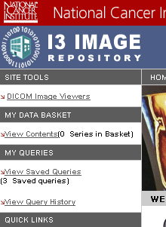

Search Results Page – Save Query Fields
The Search Results page will be changed to allow users to save the query that generated the displayed results. A text field to specify a name for saved query and a button to save the query will be added. When the button is pressed, the SearchResultBean.saveQuery action is called.
The fields will look as follows:
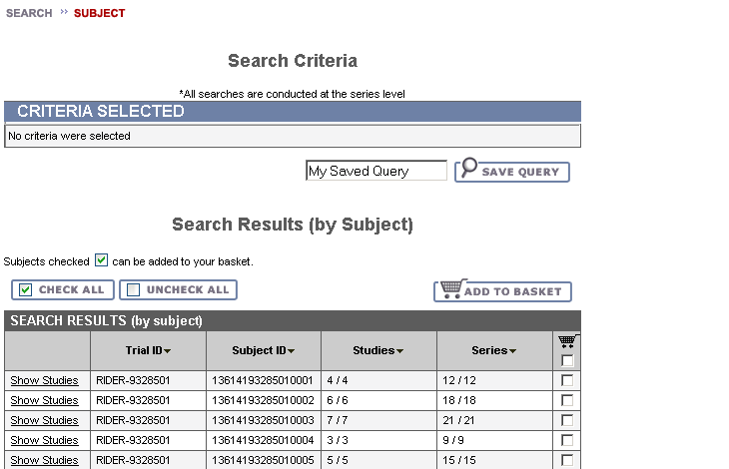
These new fields will not appear if a user is resubmitting a saved query.
When a user presses the Save Query button, the system attempts to save the query then returns the user back to the page. Based on the message provided, the user can determine success or failure and any additional actions that are required.
Message Type | Message
Information | Query ‘[Query Name]’ saved successfully.
Error | A saved query with that name already exists.
Error | Please enter a name for the query.

Manage Saved Queries
The Manage Saved Queries page is a new page that is accessed by clicking the “View Saved Queries” link in the side navigation bar. Using SavedQueryBean, the page displays a table of all queries that are currently saved for the user and appears as follows:
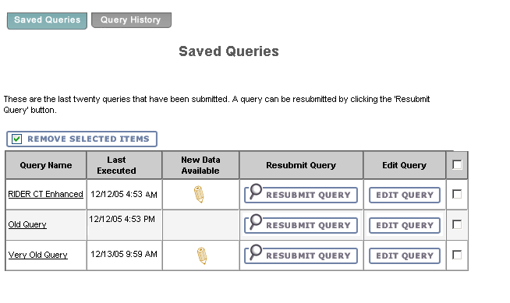
The table is sorted in descending order by Last Execute Date. The table will allow for sorting by Query Name and Last Execute Date. For each saved query, the table contains:
- An icon that can be clicked to view new data. The icon will only appear if the NewResults property of SavedQueryDTO is true. Clicking the icon calls the SavedQueryBean.showNewResults action, which causes the results (new data only) to be displayed on the Search Results page.
- The name of the query displayed as a link. The link toggles whether the criteria for the saved query are displayed. The default is that the criteria are not displayed. Criteria for the query are obtained using the CriteriaList property of the SavedQueryDTO. When shown, the criteria look as follows:
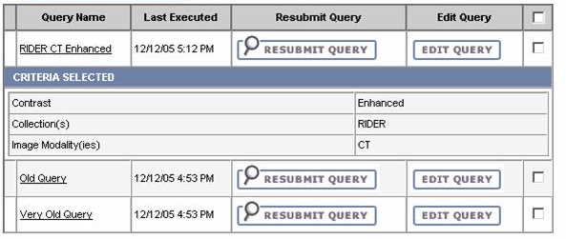
- The date and time of the last time the user executed the query in any way, obtained from the LastExecuted property of SavedQueryDTO. The time is displayed for the Eastern Time (US & Canada) timezone.
- A button to resubmit the query that calls the SavedQueryBean.resubmitQuery action. Pressing this button submits the query using the saved criteria and displays results to the user on the Search Results page.
- A button to edit the query that calls the SavedQueryBean.editQuery action. Pressing this button presents the user with the Search page displaying the criteria that was saved for the query. The user can then modify the criteria.
- A checkbox to allow for mark the query for deletion.

Other user interface components on the Manage Saved Queries page are:
- “Query History” tab – clicking this tab takes the user to the View Query History page.
- “Remove Selected Items” button – deletes any saved queries that have been selected for deletion using the query’s checkbox. The button calls the SavedQueryBean.deleteQueries action. After the system attempts to delete the queries, the user is returned to the Manage Saved Queries page. Based on the message provided, the user can determine success or failure and any additional actions that are required.
Message Type | Message
Information | Saved queries were deleted.
Error | Please select a saved query for deletion.

Search Page – Editing Saved Query
The Search page allows a user to choose the criteria that will make up their query. To edit a query, the user is presented with the Search page prepopulated with the criteria stored for that saved query. To increase usability, the name of the saved query (SearchWorkflowBean.QueryName) being edited will be shown in an information message that reads:
Saved query ‘[Name]’ is being edited. After pressing Submit and viewing the results, you will have the option to save the changes.
The page will look like this:
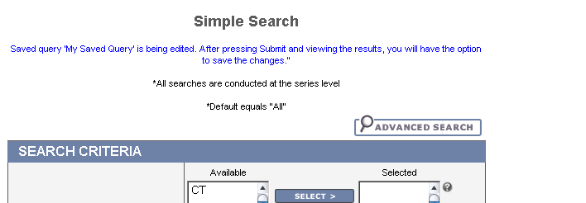

Search Results Page - Editing Saved Query
After a user has edited the criteria for a saved query, they are presented with the Search Results page showing the results returned for the edited criteria. At that point, users can choose to either update the query they are editing or create a new saved query with a different name.
To facilitate this choice, controls will be added to the Search Results page that will only appear when users are editing a saved query (SearchWorkflowBean.EditingSavedQuery = True). They will appear as follows:
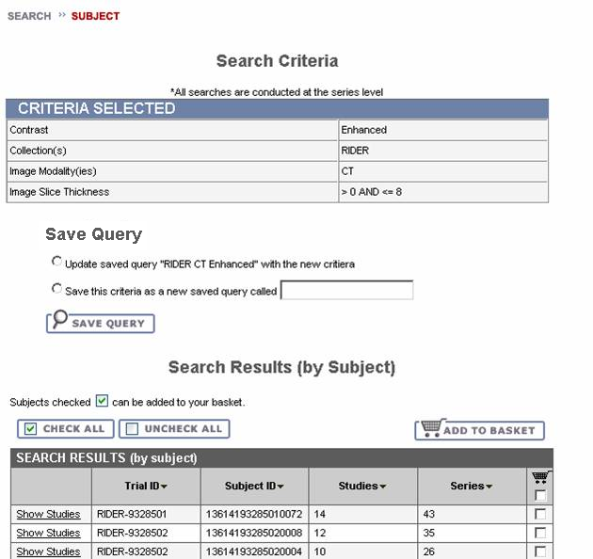
When a user presses the Save Query button, the system calls the SearchResultsBean.saveQuery action and attempts to save the query then returns the user back to the page. Based on the message provided, the user can determine success or failure and any additional actions that are required.
Message Type | Message
Information | Query ‘[Query Name]’ saved successfully.
Information | Query ‘[Query Name]’ updated successfully.
Error | A saved query with that name already exists.
Error | Please enter a name for the query.

If the user does not like the results returned by the criteria, they can navigate back to the Search page to try again.

Search Results Page – Resubmit Saved Query
When a user resubmits a saved query, the name of the saved query (SearchWorkflowBean.QueryName) will be displayed on the Search Results page to increase usability. The message will read:
These are the results of the ‘[Name]’ saved query.
As shown in this example:
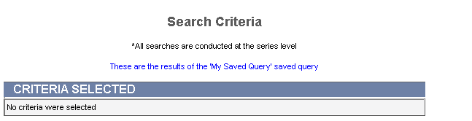
If the query is being run for new data only (determined by SearchWorkflowBean.NewDataFlag), the message will appear as follows:
These are the results of the ‘[Name]’ saved query (new data since [Date] only).
[Date] is the last execute date used a part of the criteria of the query to make it only display new results. The message is shown in this example:
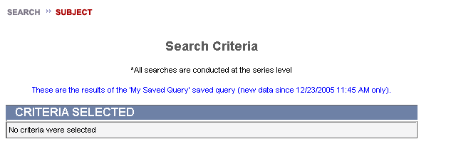

View Query History
The View Query History page is a new page that is accessed by clicking the “View Query History” link in the side navigation bar. Using QueryHistoryBean, the page displays a table of the last twenty (20) queries that the user executed. This includes any execution of a query, including both queries that are not saved and saved queries that are resubmitted. The page appears as follows:
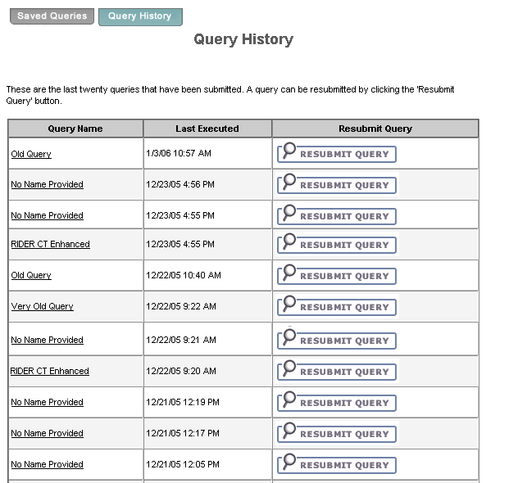

The table contains the following data for each query:
- The name of the query displayed as a link. The link toggles whether the criteria for the saved query are displayed. This is the same behavior that occurs when you click the name of a saved query on the Manage Saved Query page.
The text of the link can appear three different ways depending on the situation:
  - If the query was not saved, “No Name Provided” is displayed as a link.
  - If the query was a saved query and has not been edited since the last execution date (QueryHistory.InactiveSavedQuery = False), the name of the saved query is displayed.
  - If the query was a saved query and has been edited since the last execution date (QueryHistory.InactiveSavedQuery = True), the name of the saved query is displayed with an asterisk. The asterisk refers to a message at the bottom of the page. For example, in the screen shot below the “RIDER CT Enhanced” query has been changed.
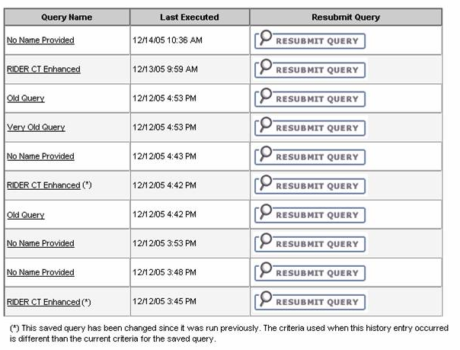
The asterisk acts as a warning to the user that the results they see will be based on the criteria that were used at the time the query was run, not the criteria that are currently saved for the saved query.
- The date and time of the last time the user executed the query in any way, obtained from the LastExecuted property of QueryHistoryDTO. The time is displayed for the Eastern Time (US & Canada) timezone.
- A button to resubmit the query that calls the QueryHistoryBean.resubmitQuery action. Pressing this button submits the query using the saved criteria and displays results to the user on the Search Results page.
The “Saved Queries” tab takes the user to the Manage Saved Queries page.

Home Page
Three small changes are being made to the home page:
- One of the goals of NCIA is to develop a community of users that can share ideas. To facilitate this, a link will be placed in the side navigation bar that will take users to a page displaying more information about NCIA along with the latest news about the project. The site in the future could contain message boards and other community building features. When a user clicks the “NCIA NEWS” link, they will be taken to the NCIA News page in a new browser window.
- An email address will be created to allow users to provide feedback and suggestions about NCIA. The email address is listed along with other support information.
- A message will be placed below the “Welcome to the In Vivo Imaging Repository” showing the last time visible images were made available. This will be obtained by getting the OverallLastUpdateDate from SearchWorkflowBean. The date reflects the last update of any images, not necessarily images that the user has access to.
The following shows all of these new features on the home page:
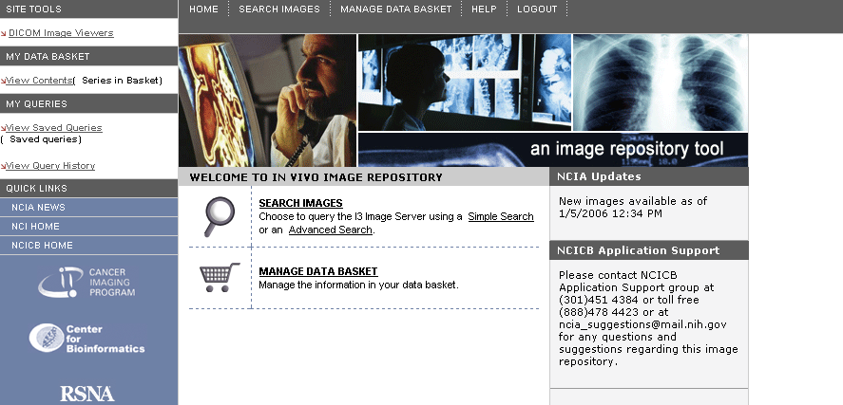

User interface Backing Beans
Using Java Server Faces (JSF), the user interface interacts with JavaBeans called backing beans to get data and perform actions. The following changes or additions are being made to backing beans:

SavedQueryDTO
The Saved Query Data Transfer Object (DTO) is a new DTO used to hold data in memory for a saved query. It will have the following attributes:
Attribute | Type | Description
Id | Integer | Primary key
NewResults | Boolean | True if there are new results since last execution date
Name | String | Name of the saved query
LastExecuted | Date | Last execution date
CriteriaList | List<Criteria> | List of the saved criteria
ShowCriteria | Boolean | True if user has clicked the link to display criteria
DeleteFlag | Boolean | True if user has clicked checkbox to mark for deletion

QueryHistoryDTO
QueryHistoryDTO is a new DTO used to hold data in memory representing a query that has been saved in the query history table. It will have the following attributes:
Attribute | Type | Description
Id | Integer | Primary key
ExecutedTime | Date | Timestamp when this query was executed
CriteriaList | List<Criteria> | List of the saved criteria
Name | String | Name to display for this query (could be default value)
InactiveSavedQuery | Boolean | True if the saved query to which this record is associated is inactive.

SearchResultsBean
SearchResultsBean manages the Search Results page. Since some actions related to saved queries can be performed from the SearchResults page, changes are required.
New attributes:
Attribute | Type | Description
NewQueryName | String | Name that the user wants to save the query under. This is populated based on the new text field added to the Search Results page.
UpdateOrSaveNew | String | Set according to user’s radio button selection on Search Results page when editing a saved query. “UPDATE” indicates that the user wants to update the existing query with the new criteria. “SAVE_NEW” indicates that the user wants to save the criteria as a new saved query with a name indicated by the NewQueryName property.

New methods:
Method | Description
saveQuery | Saves or updates a query in the database. The method determines what action to take (update or save with new name) based on the radio button selection. If there is no radio button selection (i.e. user is not editing a query), then it saves with a new name (NewQueryName). If saving with a new name, the method performs all necessary validations on the name, then calls QueryStorageManager.saveQuery() to save the query. If updating an existing saved query, it calls QueryStorageManager.updateQuery().

SearchWorkflowBean
SearchWorkflowBean is an existing backing bean that manages the process of searching. The following changes are required:
New attributes:
Attribute | Type | Description
QueryName | String | Name of the query that is being submitted. Blank if the user is not resubmitting an existing saved query.
EditingSavedQuery | Boolean | True if the user has chosen to edit an existing saved query.
NewDataFlag | Boolean | True if the user is viewing only new data for an existing saved query.
MostRecentQueryHistoryID | Integer | ID of QueryHistory record that represents the most recent query executed.

Changes to methods:
Method | Description of Change
query | The query() method is called whenever the user submits a query. In addition to running the query, this method must now record the query in the query history by calling QueryStorageManager.addQueryToHistory(). This is done to provide the user with their query history and also to keep a record of queries for reporting purposes.  Also, set the MostRecentQueryHistoryID property to the ID of the query history record created.

New methods:
Method | Description of Change
getOverallLastUpdateDate | Runs a query to get the maximum curation status date. Once it has the date, it stores the value on the bean and returns it on subsequent calls. This ensures that there will be only one database hit per session for this value.

SavedQueryBean
SavedQueryBean is a new backing bean that populates and handles actions from the Manage Saved Queries page. Its methods are as follows:
Method Name | Description
loadSavedQueries | Retrieves all saved queries for the user from the database. Calls QueryStorageManager.retrieveSavedQueries(), passing in the user ID, to get the list of queries and stores them on the bean using setSavedQueries().
getSavedQueries | Accessor for the list of saved queries
setSavedQueries | Setter for the list of saved queries
getSavedQueryCount | Returns the number of saved queries for this user obtained from the list stored on the bean.
resubmitQuery | Builds a DICOMQuery based on the saved criteria then passes the DICOMQuery to SearchWorkflowBean.query(). Also sets QueryName of SearchWorkflowBean to the name of the query being resubmitted. If NewResults=True, it calls addSavedQuery() on NewResultsFlagUpdater so that the NewResults flag will be set to False when the user logs out. Returns a value that redirects the user to the Search Results page.
viewNewData | Builds a DICOMQuery based on the saved criteria. In addition, add CurationStatusDateCriteria so that the only series returned will be those with a curation status date greater than the last execution date of the saved query. If a query has already been run during the user’s session, get the LastExecute date by calling NewResultsFlagUpdater.getLastExecuteTimeBeforeThisSession(). Then, it passes the DICOMQuery to SearchWorkflowBean.query(). Also sets QueryName of SearchWorkflowBean to the name of the query being resubmitted. Sets the NewDataFlag on SearchWorkflowBean. The method calls addSavedQuery() on NewResultsFlagUpdater so that the NewResults flag will be set to False when the user logs out. Returns a value that redirects the user to the Search Results page.
editQuery | Builds a DICOMQuery based on the saved critiera then sets it as the current query using SearchWorkflowBean.setQuery(). Also sets QueryName of SearchWorkflowBean to the name of the query being resubmitted and the EditingSavedQuery flag to true. Returns a value that redirects the user to the Search page.
deleteQueries | Calls QueryStorageManager.deleteQueries() to delete the selected queries, passing in a list of IDs to be deleted.

QueryHistoryBean
QueryHistoryBean is a new backing bean that populates and handles actions from the View Query History page. Its methods are as follows:
Method Name | Description
loadQueryHistory | Retrieves the 20 most recent query history records for the user from the database. Calls QueryStorageManager.retrieveQueryHistory(), passing in the user ID, to get the list of queries and stores them on the bean using setQueryHistory().
setQueryHistory | Accessor for the list of saved queries
getQueryHistory | Setter for the list of saved queries
resubmitQuery | Builds a DICOMQuery based on the query history record’s saved criteria then passes the DICOMQuery to SearchWorkflowBean.query(). Returns a value that redirects the user to the Search Results page. If the query was a saved query and its NewResults flag=True, the method calls addSavedQuery() on NewResultsFlagUpdater so that the NewResults flag will be set to False when the user logs out.
showCriteria | Toggles the flag for a query to indicate that the criteria should or should not be displayed.

NewResultsFlagUpdater
A saved query marked as having new results (NewResults = True) needs to be updated to NewResults=False when the query is run. This is because after a query has been run, the user has viewed all the most current results, so therefore there is no new data.
From a usability point of view, it is more consistent for a user if the same behavior occurs during their entire session whenever they click the “New Data” icon. The NewResults flag will not get updated to False until the user’s session ends (either by clicking the Logout button or by timing out). If this were not the case, the user would click “New Data”, see the new results and then would not be able to view the new results again. By waiting until their session ends to set NewResults allows the user to run the query for new results several times within the same session.
To facilitate the process of setting the flag when the session deactivates, a new class named NewResultsFlagUpdater will be created that will implement the javax.servlet. HttpSessionBindingListener interface. Objects implementing HttpSessionBindingListener are treated specially when they are added or removed from the user’s HttpSession. Upon removal of the object from the session (which occurs when the session is deactivated), the valueUnbound() method is called.
NewResultsFlagUpdater will collect a list of saved queries to have their NewResults flag updated and then wait to do the updating until valueUnbound() is called.
When a saved query with new data is run, the LastExecute value of the SavedQueryDTO is updated to the current date and time. Because of this, NewResultsFlagUpdater must store the LastExecute value that was current when the user logged in. This will allow a query with new data to be run multiple times based on the same LastExecute date.
Method Name | Description
addSavedQuery | Accepts the saved query ID and last execute date as parameters. These values are placed in a Map that tracks the list of saved queries that need their NewResults flag set to False when the user’s session ends. If query is already in list, no action is taken.
getLastExecuteTimeBeforeThisSession | Retrieves the last execute time for the saved query.
valueBound | Empty. Required as part of HttpSessionBindingListener interface.
valueUnbound | This is called automatically when the HttpSession containing this object is deactivated. The method will create SavedQuery domain classes for each ID in its list, update the NewResults flag to False, and use Hibernate3DataAccess to save.
getInstance | Static method to obtain an instance of this class. The method locates the user’s session using  FacesContext.getCurrentInstance().  getExternalContext().getSession(false);  If an instance of NewResultsFlagUpdater has already been placed in the user’s session, no action is necessary except to return the instance for the user. If it does not exist, it instantiates an instance and places it in the session.

MIDDLE TIER

QueryStorageManager
QueryStorageManager is a new class that manages persistence for saved queries and query history records. Its methods will be:
Method Name | Description
saveQuery | Creates a SavedQuery domain object and populates the following fields:  - Name  - User  - NewData (set to False)  - Active (set to True)  Creates a SavedQueryAttribute domain object for each non-transient criteria and adds them as children of the SavedQuery domain object.  Then, it uses Hibernate3DataAccess to store the SavedQuery domain object and its children.  Next, locate the QueryHistory domain object for the last query executed (SearchWorkflowBean.MostRecentQueryHistoryID). Update the SavedQuery attribute of the QueryHistory to refer to the new SavedQuery domain object created above.
retrieveSavedQueries | Uses Hibernate3DataAccess to execute a query to retrieve all active saved queries for a user and build a SavedQueryDTO for each. The query will join in the SavedQueryLastExecuted view to populate the SavedQueryDTO’s LastExecuted field. Once the saved queries have been retrieved, the criteria must be loaded for each.
updateQuery | Uses Hibernate3DataAccess to locate the SavedQuery domain object for the saved query being updated. Set the ActiveStatus to False and save the object.  Next, call saveQuery() to save a new version of the query with the same name. The new version query will become the only active record.
deleteQueries | Loads SavedQuery domain objects based on the list of IDs passed in. Updates the ActiveStatus for each to False and saves them using Hibernate3DataAccess.
addQueryToHistory | Creates a QueryHistory domain object and populates the following fields:  - ExecutionTimestamp  - SavedQuery (if applicable)  - ElapsedTime  - User  The SavedQuery field is only populated if the user is resubmitting a saved query. In situations where a user is editing a query or saving a query for the first time, the QueryHistory.SavedQuery will be updated when the query is saved.  Creates a QueryHistoryAttribute domain object for each non-transient criteria and adds them as children of the QueryHistory domain object.  Then, it uses Hibernate3DataAccess to store the QueryHistory domain object and its children.
retrieveQueryHistory | Uses Hibernate3DataAccess to execute a query to retrieve the last 20 query history records for a user and build a QueryHistoryDTO for each. The query will join in SavedQuery to populate the Name and InactiveSavedQuery fields of the QueryHistoryDTO. Once the queries have been retrieved, the criteria must be loaded for each.
getListOfActiveNoNew | Get a list of all SavedQueryDTOs for all users that have Active=True and NewResults=False. This is used by the process that updates the NewResults flag (see section 4.5).

Criteria
Criteria is the superclass for all criteria. An method will be added named isTransient() that can be overridden by Critieria subclasses. The implementation of the method in Criteria will return false, meaning that the criteria will be saved as part of a saved query and in the query history.

CurationStatusDateCriteria
SavedQueryBean.viewNewData() adds criteria to a query based on the curation status date. Since this is not currently supported, a new type of criteria must be added. CurationStatusDateCriteria will be added to the criteria package. CurationStatusDateCriteria will be non-transient criteria, meaning that it will not be saved in query history or in a saved query. It will have the following public methods:
Method Name | Description
setStartDate | Setter for the start date
getStartDate | Getter for the start date
setEndDate | Setter for the end date
getEndDate | Getter for the end date

DicomQuery
DicomQuery will be changed to support curation status date critiera. The following new methods will be added:
Method Name | Description
setCurationStatusDateCriteria | Setter for the date criteria
getCurationStatusDateCriteria | Getter for the date criteria

DicomQueryHandler
DicomQueryHandler converts the criteria stored in a DicomQuery into Hibernate Query Language (HQL). This class will be changed to create HQL based on CurationStatusDateCriteria. CurationStatusDateCriteria is “image level” critiera since the curation status date is stored on the GENERAL_IMAGE table. If no end date is specified, it is assumed to be the current system date.

ResultSetManager
ResultSetManager is responsible for the running a search based on a DicomQuery and managing the results. It currently returns a result set consisting of two sets of series, one for non-image criteria and the other for image criteria. The sets of series are then merged to produce a list of PatientDTOs.
For the process to update the NewResults flag (see section 4.5), the actual PatientDTOs do not need to be returned. The process simply needs to know whether or not any results are returned. The following method will be added:
Method Name | Description
doResultsExist | Same as getPatientList(), but instead of building a list of PatientDTOs to return, it will simply return true and exit if it finds a series that is in both sets of results. It will return false otherwise. Having this as a separate method will improve performance because the system does not need to loop through all results and build DTOs.

BACK END

Hibernate3DataAccess
See Section 3.1.

Domain Classes

QueryHistory
Description: Represents a query that was run at some time in the past.
Attribute Name | Attribute Type | Description
Id | Integer | Primary key (system generated)
User | many-to-one association to I3User | Reference to the user that executed the query
ExecutedTime | Date | Date and time when the query was run (in Eastern time zone)
SavedQuery | Many-to-one association to SavedQuery | If the query was a saved query or was saved as a saved query, this attribute refers to the SavedQuery.
ElapsedTime | Integer | Elapsed milliseconds to run the query
QueryHistoryAttributes | One-to-many association to QueryHistoryAttribute | List of criteria that comprise the query

QueryHistoryAttribute
Description: Child of QueryHistory. Represents the criteria for a QueryHistory record.
Attribute Name | Attribute Type | Description
Id | Integer | Primary key (system generated)
AttributeName | String | Fully qualified class name of the Criteria subclass that represents the criteria chosen by the user (e.g. gov.nih.nci.i2.criteria .AnatomicalSiteCriteria)
SubAttributeName | String | Used when ordering of criteria is important. In some cases, more than one value in a particular order must be stored. Each value is stored in its own row with a value in this field to indicate the order.
AttributeValue | String | Value chosen by the user for the criteria (e.g RIDER). Only one value will appear for each object. For example, if a user chooses to view data for multiple projects, there will be a QueryHistoryAttribute for each project.
ParentQuery | Many-to-one association to QueryHistory | Association to parent

SavedQuery
Description: A query that was saved by a used. Once a saved query record is created, it is never changed or deleted. If changes need to be made, the saved query record is made to be inactive and a new, active record is created with the new data. Inactive saved query records need to be kept around because query history records still point to them.
Attribute Name | Attribute Type | Description
Id | Integer | Primary key (system generated)
User | many-to-one association to I3User | Reference to the user that saved the query
Name | String | Name chosen for the query
NewResults | Boolean | True if new results exist since the last time the query was run. False otherwise.
Active | Boolean | True if the object represents the latest version of a saved query. False if the object is an older version that has been changed.
SavedQueryAttributes | One-to-many association to SavedQueryAttribute | List of criteria that comprise the query

SavedQueryAttribute
Description: Child of SavedQuery. Represents the criteria for a SavedQuery record.
Attribute Name | Attribute Type | Description
Id | Integer | Primary key (system generated)
AttributeName | String | Fully qualified class name of the Criteria subclass that represents the criteria chosen by the user (e.g. gov.nih.nci.i2.criteria .AnatomicalSiteCriteria)
SubAttributeName | String | Used when ordering of criteria is important. In some cases, more than one value in a particular order must be stored. Each value is stored in its own row with a value in this field to indicate the order.
AttributeValue | String | Value chosen by the user for the criteria (e.g RIDER). Only one value will appear for each object. For example, if a user chooses to view data for multiple projects, there will be a SavedQueryAttribute for each project.
ParentQuery | Many-to-one association to SavedQuery | Association to parent

SavedQueryLastExecuted
Description: Domain class used to access a view that contains the last execution date for a saved query. The last execution date is determined by looking at all of the associated query history records and finding the latest.
Attribute Name | Attribute Type | Description
SavedQueryId | Integer | ID of the saved query
LastExecuteDate | Date | Date/time that the saved query was last executed

Database Design

QUERY_HISTORY
Table: QUERY_HISTORY
Column Name | Column Type | Class / Attribute Name
QUERY_HISTORY_PK_ID | NUMBER | QueryHistory.Id
USER_ID | NUMBER | QueryHistory.User
QUERY_EXECUTE_TIMESTAMP | DATE | QueryHistory.ExecutedTime
SAVED_QUERY_PK_ID | NUMBER | QueryHistory.SavedQuery
ELAPSED_TIME | NUMBER | QueryHistory.ElapsedTime

QUERY_HISTORY_ATTRIBUTE
Table: QUERY_HISTORY_ATTRIBUTE
Column Name | Column Type | Class / Attribute Name
QUERY_HISTORY_ATTR_PK_ID | NUMBER | QueryHistoryAttribute.Id
ATTRIBUTE_NAME | VARCHAR2(300) | QueryHistoryAttribute.AttributeName
SUBATTRIBUTE_NAME | VARCHAR2(300) | QueryHistoryAttribute.SubAttributeName
ATTRIBUTE_VALUE | VARCHAR2(300) | QueryHistoryAttribute.AttributeValue
QUERY_HISTORY_PK_ID | NUMBER | QueryHistoryAttribute.ParentQuery

SAVED_QUERY
Table: SAVED_QUERY
Column Name | Column Type | Class / Attribute Name
SAVED_QUERY_PK_ID | NUMBER | SavedQuery.Id
USER_ID | NUMBER | SavedQuery.User
QUERY_NAME | VARCHAR2(300) | SavedQuery.Name
NEW_DATA_FLAG | NUMBER(5) | SavedQuery.NewResults
ACTIVE | NUMBER(5) | SavedQuery.Active

SAVED_QUERY_ATTRIBUTE
Table: SAVED_QUERY_ATTRIBUTE
Column Name | Column Type | Class / Attribute Name
SAVED_QUERY_ATTR_PK_ID | NUMBER | SavedQueryAttribute.Id
ATTRIBUTE_NAME | VARCHAR2(300) | SavedQueryAttribute.AttributeName
SUBATTRIBUTE_NAME | VARCHAR2(300) | SavedQueryAttribute.SubAttributeName
ATTRIBUTE_VALUE | VARCHAR2(300) | SavedQueryAttribute.AttributeValue
SAVED_QUERY _PK_ID | NUMBER | SavedQueryAttribute.ParentQuery

SAVED_QUERY_LAST_EXEC
View: SAVED_QUERY_LAST_EXEC
DDL:
select sq.saved_query_pk_id, max(qh.query_execute_timestamp)
from saved_query sq, query_history qh
where qh.saved_query_pk_id = sq.saved_query_pk_id
group by qh.saved_query_pk_id

Column Name | Column Type | Class / Attribute Name
SAVED_QUERY_PK_ID | NUMBER | SavedQueryLastExecuted.SavedQueryId
LAST_EXECUTE_DATE | DATE | SavedQueryLastExecuted.LastExecuteDate

Indexes
To improve performance, indexes will be added as follows. These indexes are in addition to any primary key, unique, or referential integrity constraints.
Index Name | Table Name | Column(s)
SAVED_QUERY_USER_IDX | SAVED_QUERY | USER_ID
QUERY_HISTORY_USER_IDX | QUERY_HISTORY | USER_ID
QUERY_HIST_SAVE_QUER_IDX | QUERY_HISTORY | SAVED_QUERY_PK_ID

The first two indexes need to be added because the SAVED_QUERY and QUERY_HISTORY tables will frequently be queried to get a list of data for a particular user.
The third index is needed to improve performance of the SAVED_QUERY_LAST_EXEC view. In that view, QUERY_HISTORY records will be grouped by the SAVED_QUERY_PK_ID column.

PROCESS TO UPDATE NEW DATA FLAG
When a user chooses to save a query, the NewResults flag is initially set to False. Whenever a saved query is submitted and the user logs out, the NewResults flag is reset to False. To set the flag to True, a process is needed to check for new data whenever new images are made visible.
Images are submitted to NCIA through MIRC software. Submitted images are not visible until they have been curated by a subject matter expert to check for image quality and to ensure there is no identifiable information in the image. The current process for curation involves the curator creating a list of series IDs to be made visible. This list is fed to a process that updates the visibility flags and other data for the images and the associated series, studies, and patients. The process is an offline “batch” process typically run at a time that will not affect online performance.
For Release 1.2, the process will be extended to check for new data for saved queries. Upon completion of the visibility update process, the system will perform the following process:
- Call QueryStorageManager.getListOfActiveNoNew() to get a list of all SavedQueryDTOs that have Active=True and NewResults=False.
- For each SavedQueryDTO:
  - Build a DICOMQuery object based on the saved criteria.
  - In addition to the saved critiera, add CurationStatusDateCriteria so that the only series returned are those with a curation status date greater than the SavedQueryDTO’s LastExecuted attribute.
  - Pass the DICOMQuery to the ResultSetManager.doResultsExist() method.
  - If the method returns True, update the SavedQuery’s NewResults attribute to True and save the SavedQuery.
  - If the method returns False, there are no new results and the NewResults flag does not need to be updated.
The running of this process does not add any QueryHistory records since the queries are not being executed by a user.

